**Exercise**



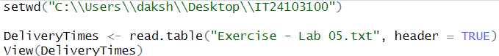



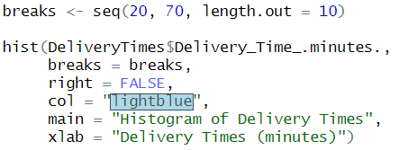



The distribution is approximately symmetric, with most delivery times clustered around the center (40–45 minutes).





